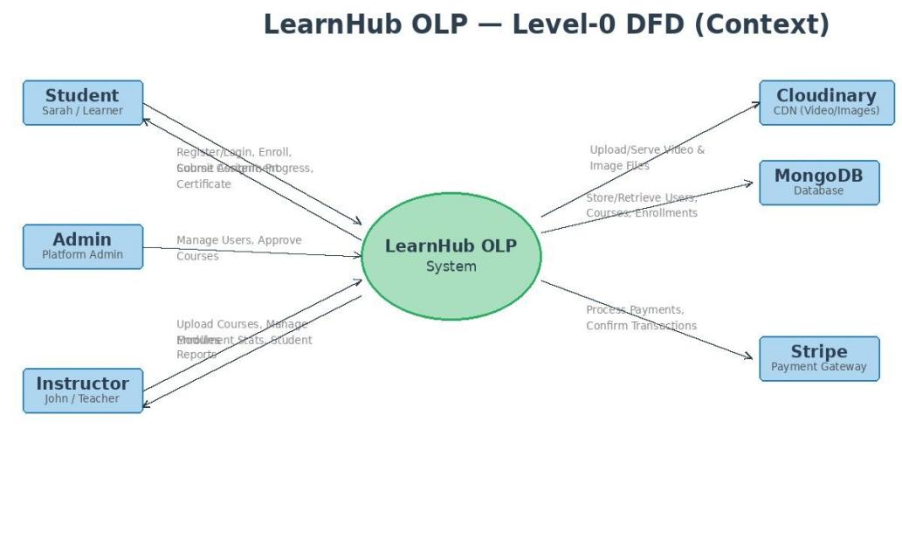
Project Design Phase-II

Data Flow Diagram & User Stories

Date | 17 February 2026
Team ID | LTVIP2026TMIDS78241
Project Name: | LearnHub — Online Learning Platform (OLP)
Maximum Marks | 4 Marks

Data Flow Diagrams:
A Data Flow Diagram (DFD) is a traditional visual representation of the information flows within a system. A neat and clear DFD can depict the right amount of the system requirement graphically. It shows how data enters and leaves the system, what changes the information, and where data is stored.
Example: DFD Level 0 (Industry Standard)

Example: LearnHub OLP Level-0 DFD
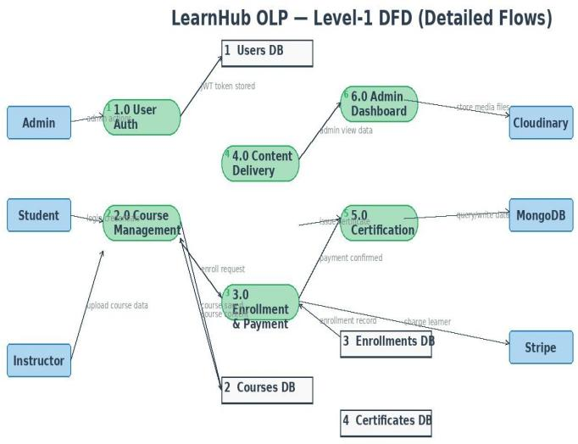

User Stories
Use the below template to list all the user stories for the product.

User Type | Functional Requirement  (Epic) | User Story Number | User Story / Task | Acceptance criteria | Priority | Release
Student (Mobile  / Web User) | Registration | USN-1 | As a user, I can register for the application by  entering my email, password, and confirming my password. | I can access my account / dashboard | High | Sprint-1
 |  | USN-2 | As a user, I will receive confirmation email once I have registered for the application | I can receive confirmation email & click confirm | High | Sprint-1
 |  | USN-3 | As a user, I can register for the application using their Google account via OAuth 2.0 | I can register and access my dashboard using  Google OAuth 2.0 Login | Low | Sprint-2
 |  | USN-4 | As a user, I can register for the application through Gmail |  | Medium | Sprint-1
 | Login | USN-5 | As a user, I can log into the application by entering email & password |  | High | Sprint-1
 | Dashboard
Student (Web User) | Course Catalog & Enrollment | USN-6 | As a student, I can browse and search the LearnHub course catalog by category,  difficulty, and name | Course list is visible and filterable by category and  level | High | Sprint-1
Instructor (John) | Course Management | USN-9 | As an instructor, I can create, edit, and publish courses with sections, videos, and  assignments | Course is visible to enrolled students after  publish | High | Sprint-2
Admin | Platform Administration | USN-12 | As an admin, I can view all users, manage enrollments, approve courses, and monitor  platform activity | Admin dashboard shows real-time stats | High | Sprint-2

